Story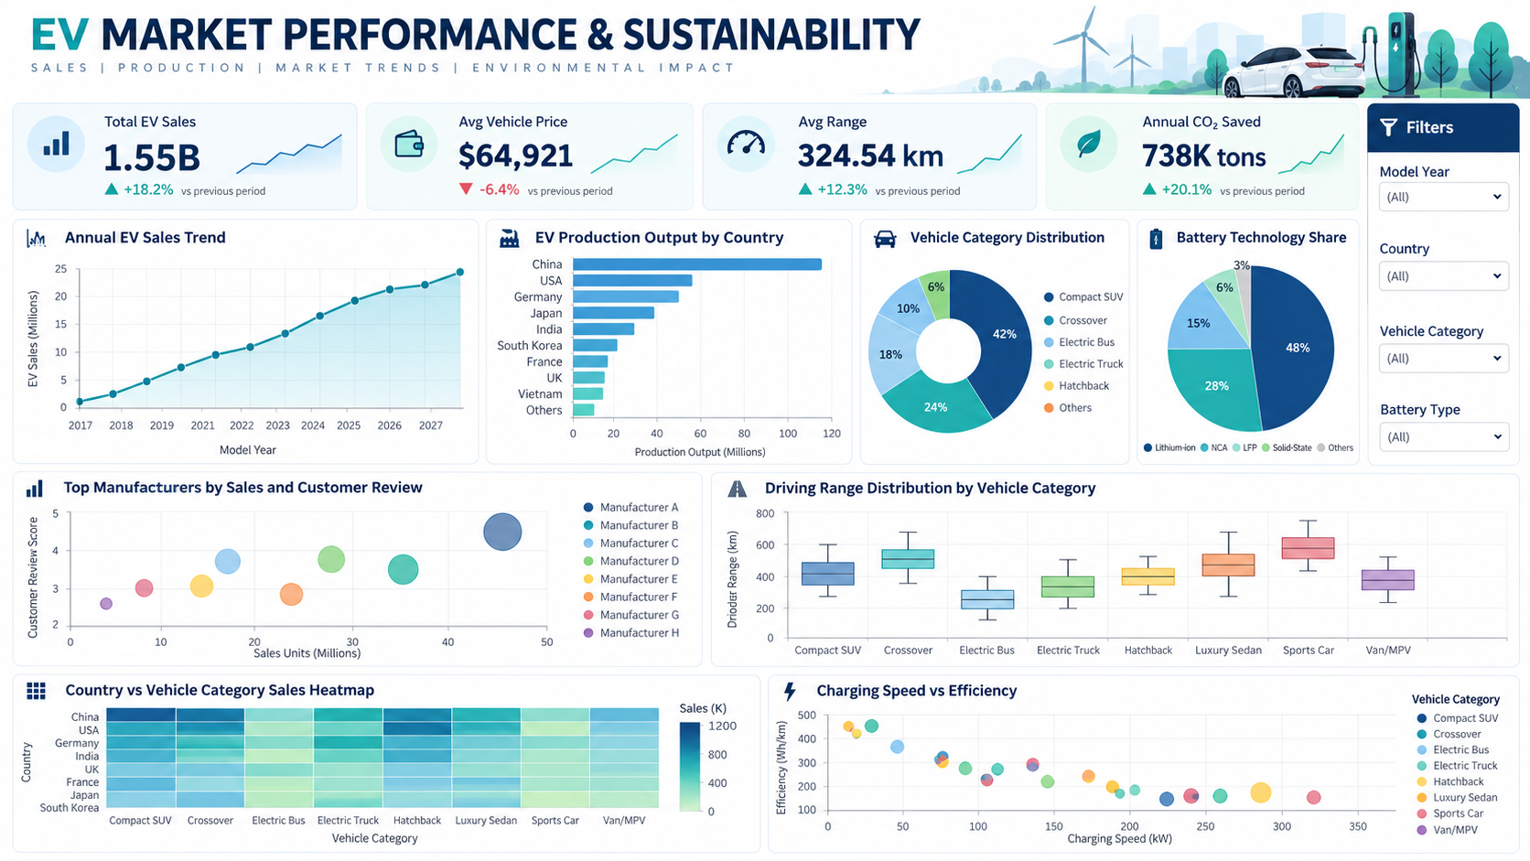

Date | 24 September 2024
Team ID | Individual
Project Name | EV Market Performance & Sustainability Analytics
Maximum Marks | 5 Marks

By using stories in Tableau, you can effectively communicate complex data in a way that is both interactive and engaging, making it easier for the audience to follow along and understand the insights. It’s a tool for data storytelling, allowing you to present insights in a cohesive, engaging way that takes viewers through a logical progression of findings or analyses.
In Tableau, Story is a feature that allows you to create a sequence of dashboards, visualizations, and text to present data insights in a cohesive and narrative-driven way. It's like a slideshow within Tableau that guides the audience through a series of data points, helping them understand key insights, trends, or outcomes of your analysis.

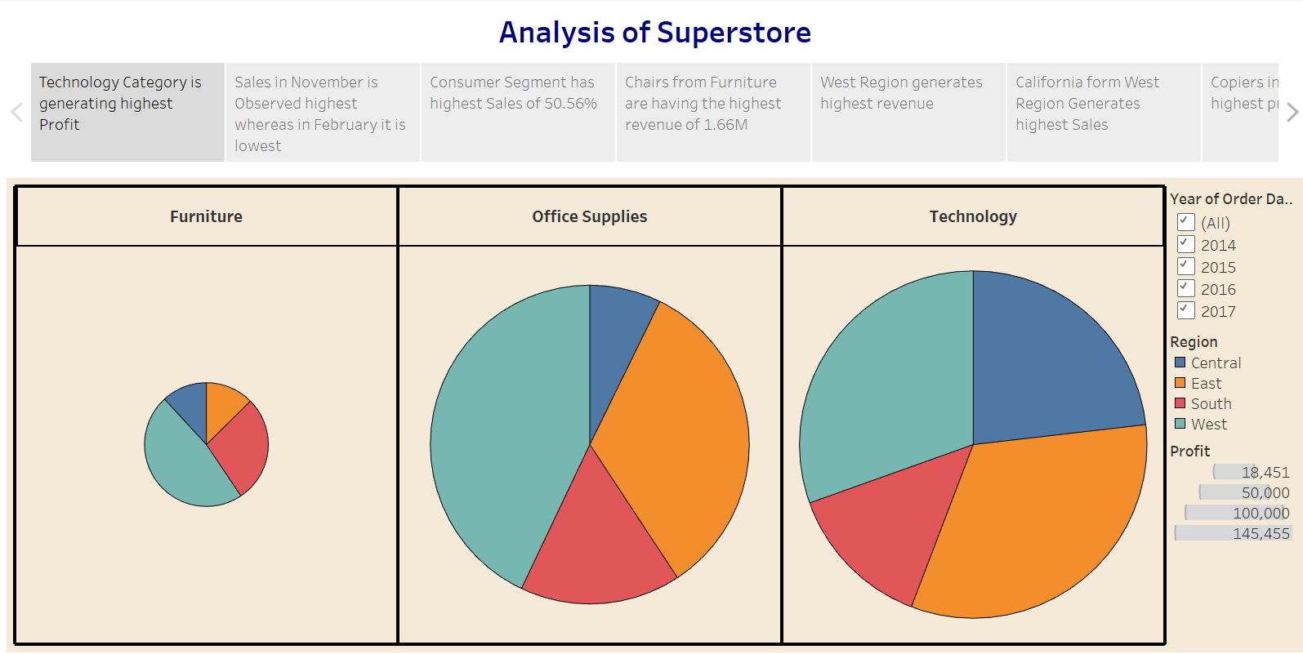

Observations:
- EV Sales Scale: The dataset records approximately 1.55 billion annual sales units across the available vehicle records.
- Average Vehicle Price: The average listed vehicle price is approximately $64,921, providing a baseline for market positioning analysis.
- Driving Range: The average driving range is approximately 324.54 km, allowing comparison of range performance across vehicle categories.
- Environmental Impact: The dataset reports approximately 737.93 thousand tons of CO₂ saved per year in total.

Activity 2:
Publish Story on Tableau Public and Paste Public link below

https://public.tableau.com/views/final_17930935412820/Dashboard1?:language=en-US&:sid=&:redirect=auth&:display_count=n&:origin=viz_share_link

